

Active Travel – Quarterly Claim Forms (The Annexes):

Application Guidance for the completion & submission of the ATF Quarterly Claims Forms (The Annexes)

December 2022

This guidance has been prepared by Transport for Wales for Local Authorities. Its purpose is to provide Guidance for the completion & submission of the ATF Quarterly Claims Forms (The Annexes). For enquiries or any issues with access to our Portal please contact the TfW Grant Management team by emailing: [grants@tfw.wales](mailto:grants@tfw.wales)

Table of Contents

1. **Logging into the Portal** 3

2. **Annex A** 4

3. **Annex B** 6

4. **Annex C** 9

5. **Annex E** 12

# **Logging into the Portal**

**To complete/ Upload your Quarterly Claim forms you will need to Log in to the Portal** [**here**](https://trcsrg.powerappsportals.com/SignIn?returnUrl=%2F)

*If you are encountering problems or are unable to access your online account,*

*please contact the TfW Grant Management Team* [*grants@tfw.wales*](mailto:grants@tfw.wales)

**Click the Active Travel Quarterly Returns (All Applications) button**

# **Annex A**

**In preparation for the completion of your Quarterly Returns, the** [**grants@tfw.wales**](mailto:grants@tfw.wales) **team will have created, populated, and posted your Annex As onto the portal for you based on the information provided in your previous claim.**

*Meaning you will no longer need to create these and will simply have to update the information provided in line with project progress.*

**Your pre-populated Annex A’s will be Live in the system for your review and editing on the 15th of the month before your quarterly submission deadline.**

|  |  |  |
| --- | --- | --- |
| **Quarter** | **GO -LIVE** | **Completion Deadline** |
| Q1 | 15th June | 15th July |
| Q2 | 15th September | 15th October |
| Q3 | 15th December | 15th January |
| Q4 | 15th March | 30th April |

**If you have not already done so, please follow the steps to login into the portal.**

**Now select Annex A list as shown below**

**On the next screen you will be taken to a list of ‘Unsubmitted’ Annex’s. Below are some examples.**

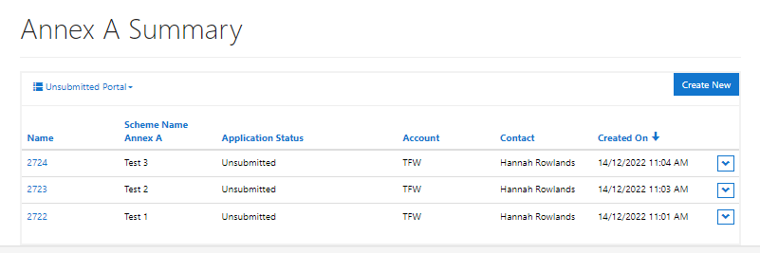

**Using the drop-down arrows on the right-hand side of each project you will be able to select to View/ Edit the Annex for that specific project.**

**Make the necessary amendments to the Annex**

**Once you have finished completing or editing the form, scroll right down to the bottom of the Annex and click Save**

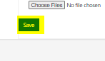

**You can go in & out of the Annex As to edit them as many times as you would like until you are ready to submit – at which point you will need to click the down arrow (as shown in Step 3c above) and select ‘Submit Application’**

*Note: Once you have selected ‘Submit Application’ – you will no longer be able to update the Annex yourselves. Email requests can be sent to* [*grants@tfw.gov.uk*](mailto:grants@tfw.gov.uk) *mailbox for amendments to be made on your behalf.*

# **Annex B**

**In preparation for the completion of your Quarterly Returns, you will receive an email from the** [**grants@tfw.wales**](mailto:grants@tfw.wales) **team containing your latest Annex B, C & a blank Annex E**

**For Annexes B & C there will be sections that are highlighted, along with a Key so that you can easily identify where your input is required.**

**Email Example:**

**Annex B example:**

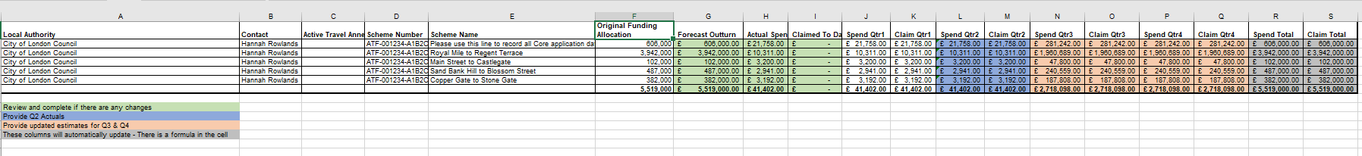

**Take a closer look at the key:**

**Once your amendments have been made, click to SAVE the file to your desktop and move to the Portal** [**here**](https://trcsrg.powerappsportals.com/SignIn?returnUrl=%2F)

*(For instructions on how to login to the Portal please go to Step 1. Logging in to the Portal)*

**On the Homepage you’ll need to click the ‘Active Travel Quarterly Returns (All Applications)’ button.**

**Click Annex B Upload**

**On the next page click the ‘Choose file’ button ready for your file to be uploaded**

**Select the relevant file for upload > Click Open**

**Make sure that the file has been uploaded by reviewing the file name that appears under the Attach File heading. If the correct file has been uploaded, click Submit**

**You have now successfully uploaded your Annex B**

# **Annex C**

**In preparation for the completion of your Quarterly Returns, you will receive an email from the** [**grants@tfw.wales**](mailto:grants@tfw.wales) **team containing your latest Annex B, C & a blank Annex E**

**For Annexes B & C there will be sections that are highlighted, along with a Key so that you can easily identify where your input is required.**

**Email Example:**

**Annex C example:**



**Take a closer look at the key:**

**Once your amendments have been made, click to SAVE the file to your desktop and move to the Portal** [**here**](https://trcsrg.powerappsportals.com/SignIn?returnUrl=%2F)

*(For instructions on how to login to the Portal please go to Step 1. Logging in to the Portal)*

**On the Homepage you’ll need to click the ‘Active Travel Quarterly Returns (All Applications)’ button.**

**Click Annex C Upload**

**On the next page read the declaration and select Yes**

**Click the ‘Choose file’ button ready for your file to be uploaded**

**Select the relevant file for upload > Click Open**

**Make sure that the file has been uploaded by reviewing the file name that appears under the Attach File heading. If the correct file has been uploaded, click Submit**

**You have now successfully uploaded your Annex C**

# **Annex E**

**In preparation for the completion of your Quarterly Returns, you will receive an email from the** [**grants@tfw.wales**](mailto:grants@tfw.wales) **team containing your latest Annex B, C & a blank Annex E.**

**As mentioned above, unlike Annexes B & C, the Annex E will be blank.**

**It is in the Annex E that you will be required to list your expenditures.**

*Note: If a nil claim is to be submitted – No Annex E is required (but an Annex C will still be required)*

*Copies of Invoices must be provided for any invoices over 40k.*

**Example Email:**

**Example Annex E:**

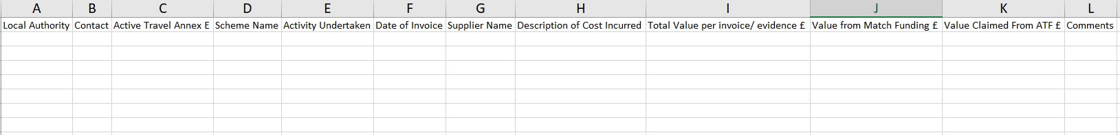

**Once your amendments have been made, click to SAVE the file to your desktop and move to the Portal** [**here**](https://trcsrg.powerappsportals.com/SignIn?returnUrl=%2F)

*(For instructions on how to login to the Portal please go to Step 1. Logging in to the Portal)*

**On the Homepage you’ll need to click the ‘Active Travel Quarterly Returns (All Applications)’ button.**

**Click Annex E Upload**

**Select the relevant file for upload > Click Open**

**Make sure that the file has been uploaded by reviewing the file name that appears under the Attach File heading. If the correct file has been uploaded, click Submit**

**You have now successfully uploaded your Annex E**